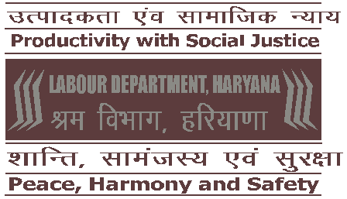
Government of Haryana
Labour Department
30 Bays Building, Sector 17, Chandigarh
(Website: hrylabour.gov.in)

Notice Inviting Tender
for operating 24 canteens at District Headquarters of the State (Zone-wise) for providing subsidized food under “Antyodaya Aahar Yojana”

The Labour Department, Haryana invites bid from the interested bidders for rendering the services to operate 24 canteens at the District Headquarters of the State (Zone-wise) established under the “Antyodaya Aahar Yojana”.
A complete set of tender document including scope of work, composition of the diet and details of the scheme alongwith terms and conditions can be downloaded from the Labour Department’s website “hrylabour.gov.in” or from the website “https://etenders.hry.nic.in”.
Interested company/ society / firm / contractor / organization (private or government) / registered NGO / charitable trust having relevant work experience may submit their bid alongwith documents confirming the compliance mentioned in the tender document by 03:00 P.M. of 15.03.2019 on the website “https://etenders.hry.nic.in” only. No off-line application in this regard will be entertained by the Department.

LABOUR COMMISSIONER – cum-
SECRETARY, HARYANA BUILDING & OTHER
CONSTRUCTION WORKERS’ WELFARE BOARD

